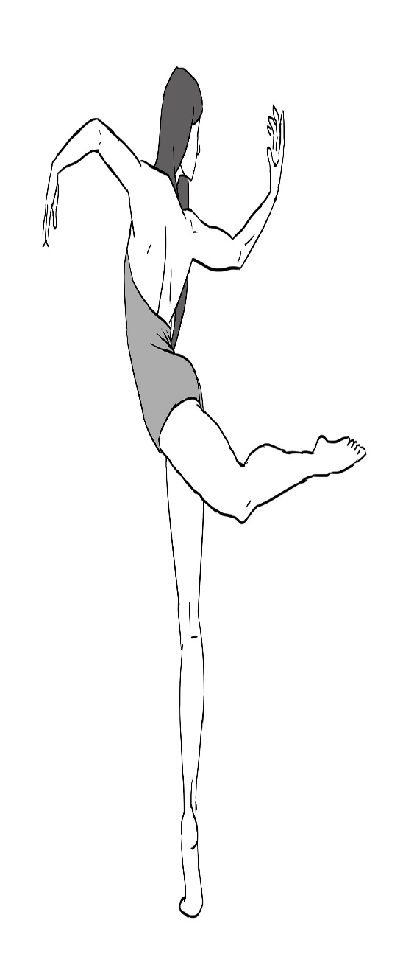
Composition 4
T,TH 9:00 am – 12:00 noon
Instructor – Courtney D. Jones

Required attire: Ladies – Colored Leotard and black or pink tights. Men- Black tights, Solid color
T-Shirt tucked into tights or colored leotard. Hair must be worn up and secured to head. No warm-ups, jazz pants, jewelry or socks.

Course Objective: Improvisation/Choreography – Space, Time, Energy, Levels, Dynamics, Patterns, Form and Tempo.

Students will express ideas and interpret images found in the environment through movement. You will be able to improvise and demonstrate original movement and perform basic compositional forms using fundamental choreographic processes. You will be able to incorporate appropriate movement vocabulary when identifying qualities and discussing meaning or performance and production in dance and distinguish commonalities between dance and other subject areas.

Course Requirements:
75% Choreographic Assignments, Daily Participation, Journal Assignments
15% Exams, Quizzes and Final Exam
10% Review, Volunteer Assignment, Notebook Assignments, Artist Statement

Notebook
Your notebook should be brought to every class. Organization is very important (use time-trackers). Notebook/ 1 inch 3-ring binder with pockets and divided into 5 sections with dividers labeled:

- Class Overview & Assignment Calendar/Info
- Notes
- Notebook Assignments (Always be prepared for random GRADED Notebook checks)
- Choreographic Studies/ Journal Assignments
- Quiz/Exams

NO LATE WORK WILL BE ACCEPTED FOR WRITTEN ASSIGNMETS
CHEATING OF ANY KIND WILL RESULT IN AN AUTOMATIC ZERO AND P IN CONDUCT

Notebook Assignments – Due Tuesday – September 27, 2016
- Dance Card/Zest Dance Calendar – Houston Dance Events
- Attend/Volunteer at a Professional Dance Event in Houston and write a review about event and volunteer duties. – Due, Tuesday, September 27th.
- Dance Photos – 3 with description – Must include: dancer/choreographer, photographer credit, title of piece if applicable, and why you relate or connect to the images.
- Artist Statement-

Journal Assignments
- Journal Assignments are due the following class. 5 points will be deducted from grade every day assignment is late. You may email your journal assignments to: cjones46@houstonisd.org. I will accept assignments on time if posted by 1:00 pm day assignment is due. You may also turn in a typed hard copy in class if you prefer.
- Questions are expected to be answered in complete sentences, with correct spelling and legibility. I expect a lot of thought and introspection in all responses.
- Many times journal assignments might feel like “busy work.” Please do not take this position. I do read your journals and often find the entries to be personal and to provide a deeper insight and understanding into your opinions on reflection and composition.

Final Exam – Music Selection Due Tuesday – September 6, 2016
- You will need to find two contrasting music selections that you will potentially use for your final exam.
- The music selections must be recorded on a cassette or CD by you to turn in on Tuesday, September 6th.
- Music selections must be a minute and a half to two minutes in length and have no lyrics. Let me repeat myself NO LYRICS!
- Selections should be faded out. ( I can help) No splicing or chopping of music.
- Look for music that has several dynamic changes, tempo, climax and interesting instrumentation. What music would you use for ARTS if you were a senior?
- Review Doris Humphrey’s checklist about music before turning in proposals.
- You will receive a grade on submission of tapes and the selections you have chosen.
- Do not wait to the last minute.

Plagiarism in Composition and Choreography
With the vast amount of dance accessible through attending live performances, dance conventions and competitions and reality television it can become easy for a young choreographer to confuse being inspired by the creations of others than actually crafting their own work. By signing the attached moral clause, the student is stating that to the best of their knowledge they are presenting a compositional study and/or choreographic work that is of their own artistic conception and construction. Always remember to ask yourself: “Am I being a responsible artist and further, how would I feel if someone stole my work and presented it as their own?”

HSPVA Dance Composition 4 Moral Clause and HONOR CODE
I pledge that to the best of my knowledge I am presenting a compositional study and/or choreographic work that is of my own artistic conception and construction.

__________________________________ _____________
Student Signature Date

