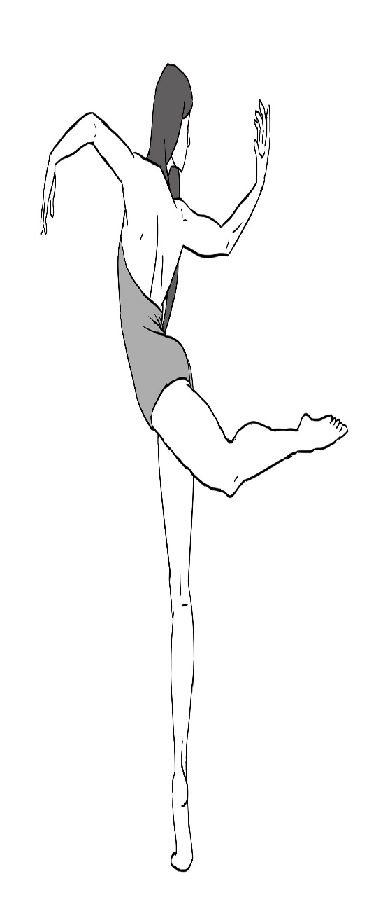
COMPOSITION 4 CHOREOGRAPHIC STUDY EVALUATION

NAME: DATE: CHOREOGRAPHIC STUDY:
______________________________________________________________________________________________________________________________

COMMENTS:

______________________________________________________________________________________________________________________________

DID THE STUDY?

STAND ON IT’S OWN? (10 pts) __________________
HAVE UNITY? (10 pts) __________________
CONSTRASTING MOVEMENT (10 pts) __________________
DEVELOP LOGICALLY? (10 pts) __________________
RESOLVE ITSELF? (10 pts) __________________
HAVE APPEALING DYNAMIC MOVEMENT? (10 pts) __________________
DID THE CHOREOGRAPHER/PERFORMER?

PERFORM WITH CONFIDENCE (10 pts) __________________
HAVE CLEAR FOCUS (10 pts) __________________
ADDRESS/ANSWER THE CHOREOGRAPHIC ASSIGNMENT? (20 pts) __________________

TOTAL GRADE __________________

